**LAB # 05**

**Sorting on Linear Array**

**OBJECTIVE:** To sort a linear array using Selection Sort, Bubble Sort and Merge Sort.

**Lab Tasks:**

1. Write a program for Selection sort that sorts an array containing numbers, prints all the sort values of array each followed by its location.

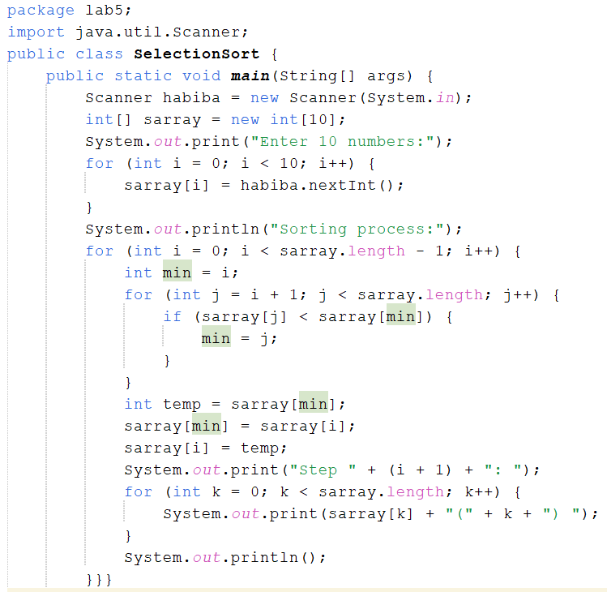

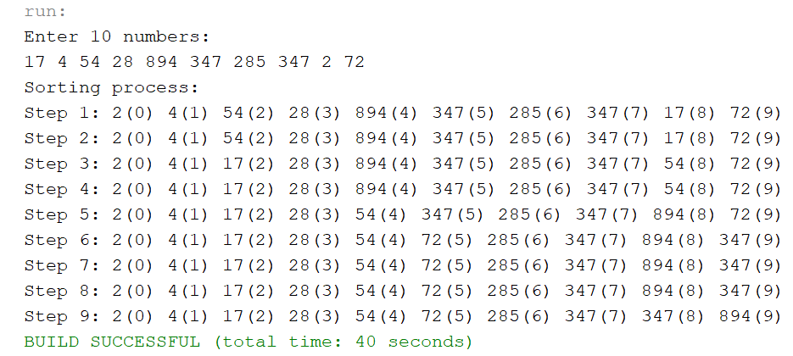

1. Write a program that takes 10 numbers as input in an array. Sort the elements of array by using Bubble sort. Print each iteration of the sorting process.

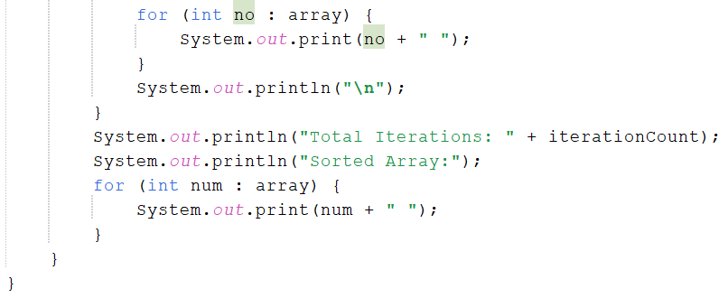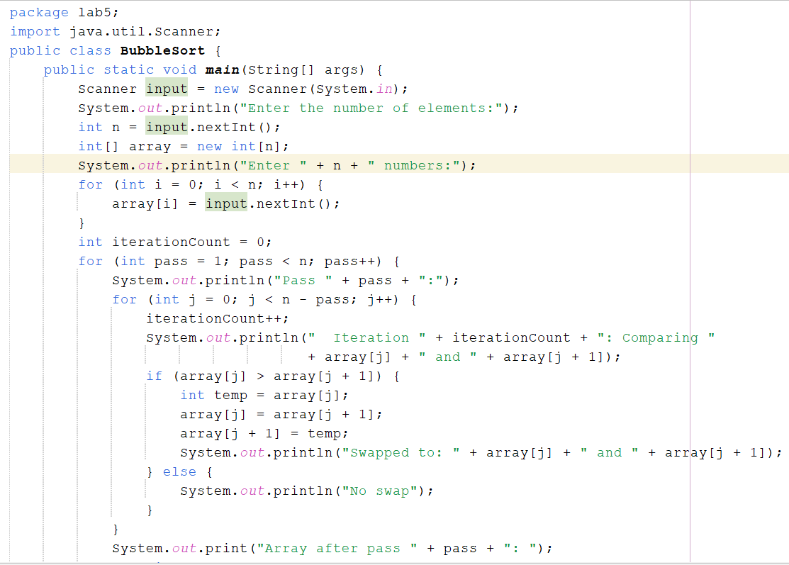

**OUTPUT:**

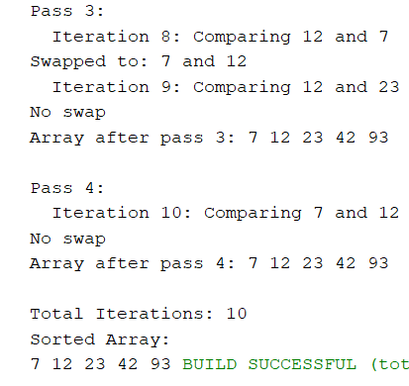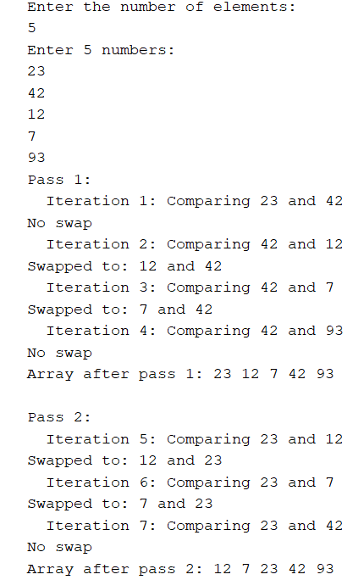

3. Write a program that takes 10 random numbers in an array. Sort the elements of array by using Merge sort applying recursive technique. Print each iteration of the sorting process.

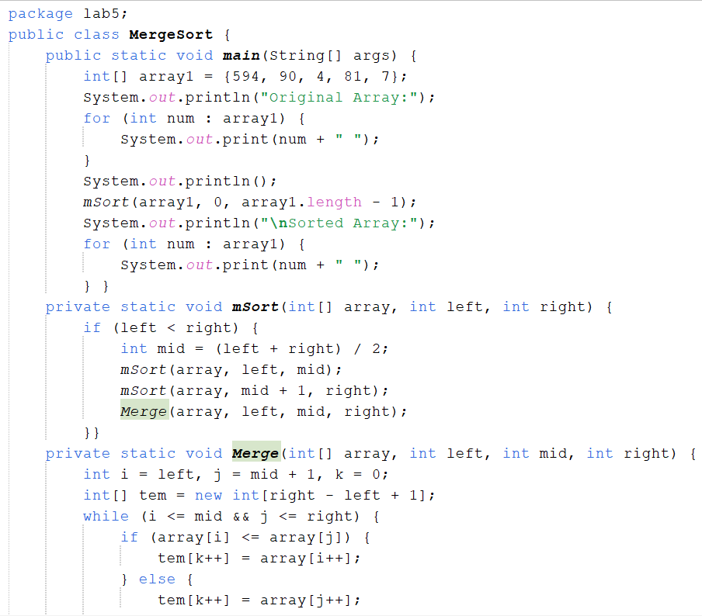

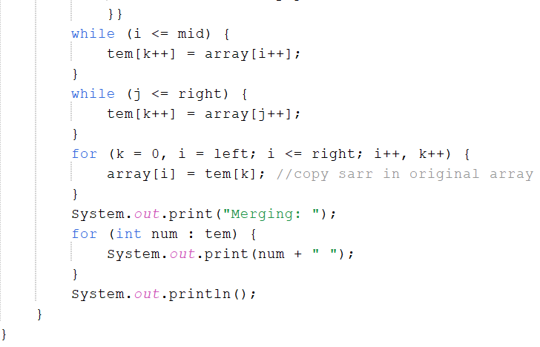

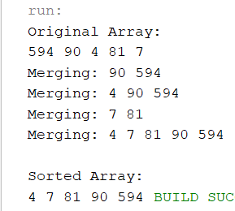

**Home Tasks:**

1. Declare an array of size n to store account balances. Initialize with values 0 to 100000 and sort Account No’s according to highest balance values by using Quick sort, For e.g.:

Account No. 3547 Balance 28000

Account No. 1245 Balance 12000

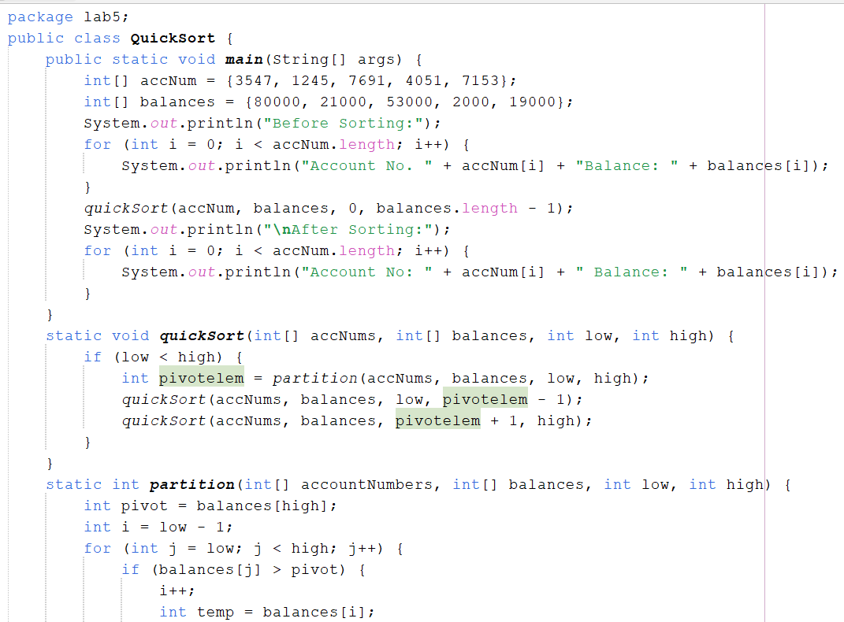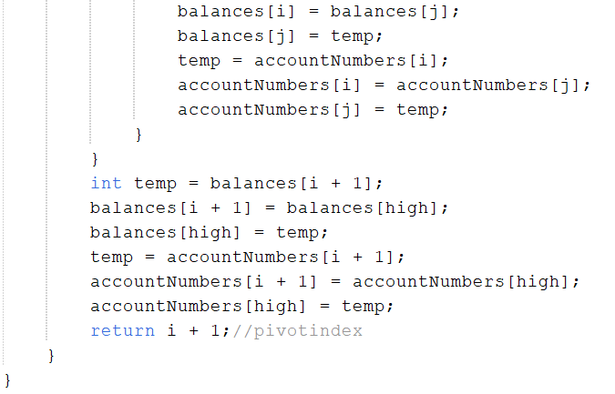

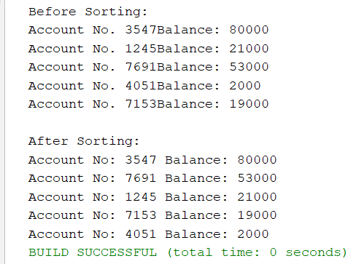

2. Write a program which takes an unordered list of integers (or any other objects e.g. String), you have to rearrange the list in their natural order using merge sort.

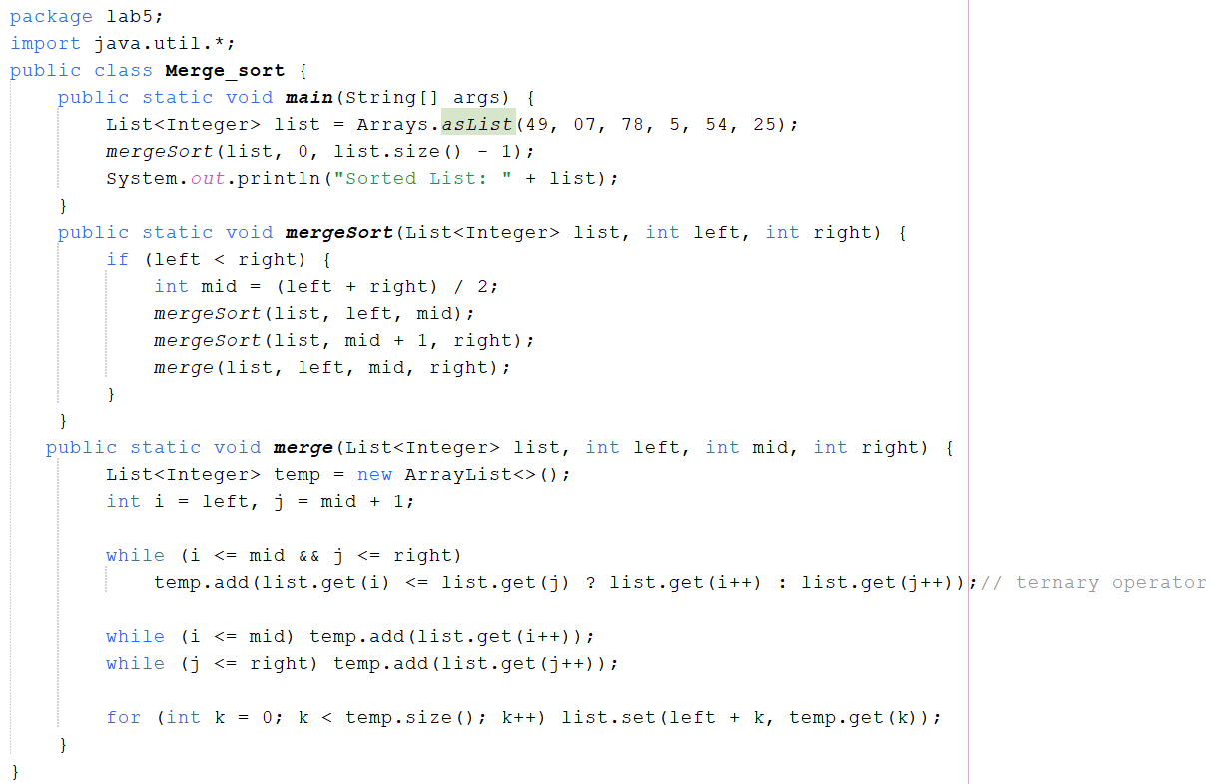

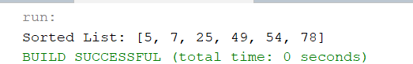

1. You are given an unordered list of integers or strings. Write a program to Take this list as input. Sort it in natural order using Merge Sort. For integers, this means ascending order. For strings, this means alphabetical order. Print the sorted list.

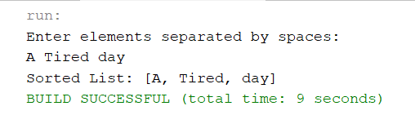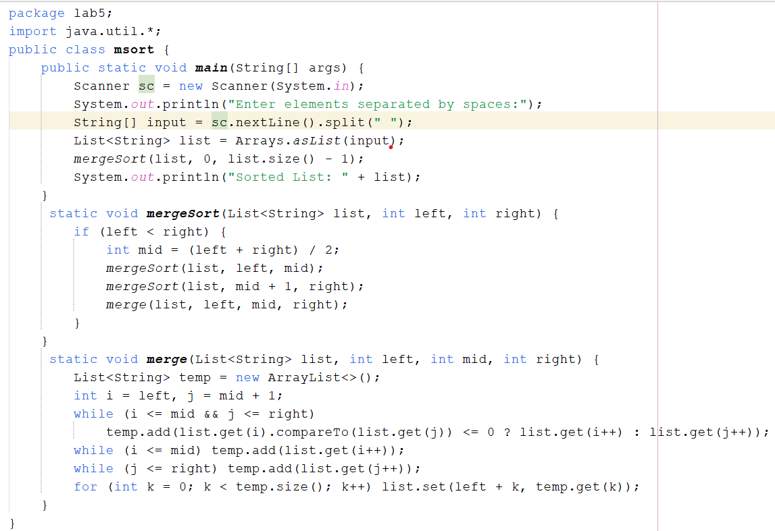

1. You are given a set of bank accounts, each with a unique account number and a balance. Write a Java program to Declare an array of size n to store account balances. Initialize each balance randomly with values between 0 and 100,000. Sort the accounts in descending order of their balances using Quick Sort. Print the sorted list in the format.

